@Component vs @Service vs @Repository (Semantic vs Functional)

Spring provides three stereotype annotations for defining beans:
- @Component
- @Service
- @Repository
At a surface level, all three do the same thing:
They register a class as a Spring-managed bean.
But in a real Spring application, they are not interchangeable.
Spring differentiates them in two important ways:
- Semantic meaning (what role the class plays in the system)
- Functional behavior (what extra features Spring applies)

1. @Component — Generic Bean
@Component is the base stereotype.
It means:
“This class is a Spring-managed object.”
It does not tell Spring:
- whether this class is business logic
- whether it talks to a database
- whether it needs transactions
- whether it needs persistence error handling
It simply says:
“Create an object and keep it in the container.”

Example:
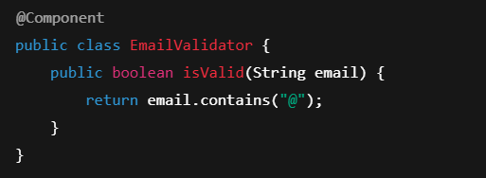
@Component has no special runtime behavior.
It only makes the class eligible for dependency injection.

2. @Service — Business Logic Layer
@Service is a specialization of @Component.
It tells Spring:
“This class represents business logic.”
This is semantic — but also functional.
Spring treats @Service beans as:
- Candidates for transaction management
- Targets for business-layer AOP
- Core application logic
Example:
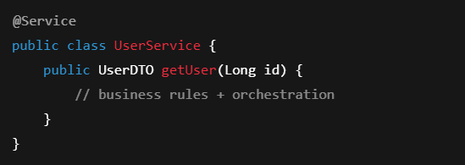

Why Spring needs this:
- Business logic often needs:
  - Transactions
  - Security
  - Caching
  - Logging
Spring applies these cross-cutting concerns mainly around @Service beans.
So @Service is not just naming —
it marks the heart of the application.

3. @Repository — Data Access Layer
@Repository is also a specialization of @Component.
It tells Spring:
“This class talks to the database.”
But it has a very important extra behavior:
Exception Translation
When a database error occurs, Spring will:
- Catch low-level exceptions (SQLException, HibernateException, etc.)
- Convert them into Spring’s unified exceptions (DataAccessException)
This only happens for beans marked as @Repository.
Example:
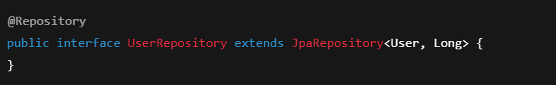
If you mark this as @Component instead:
- Spring will not translate database exceptions
- Your service layer will see raw persistence exceptions
So @Repository is functionally different.
Semantic vs Functional Difference
Annotation | Semantic Meaning | Functional Behavior
@Component | Generic Spring bean | No special behavior
@Service | Business logic | Transaction, AOP, orchestration
@Repository | Data access | Exception translation, persistence handling

Why Spring Doesn’t Want You to Use @Component Everywhere
You can use @Component everywhere.
But then Spring cannot understand:
- Which class is business logic
- Which class is database access
- Where to apply transactions
- Where to translate exceptions
Spring’s power comes from knowing the role of each class.
That’s why it gives you:
- @Service for business logic
- @Repository for data access
- @Component for everything else

Complete Layered Architecture + Annotations

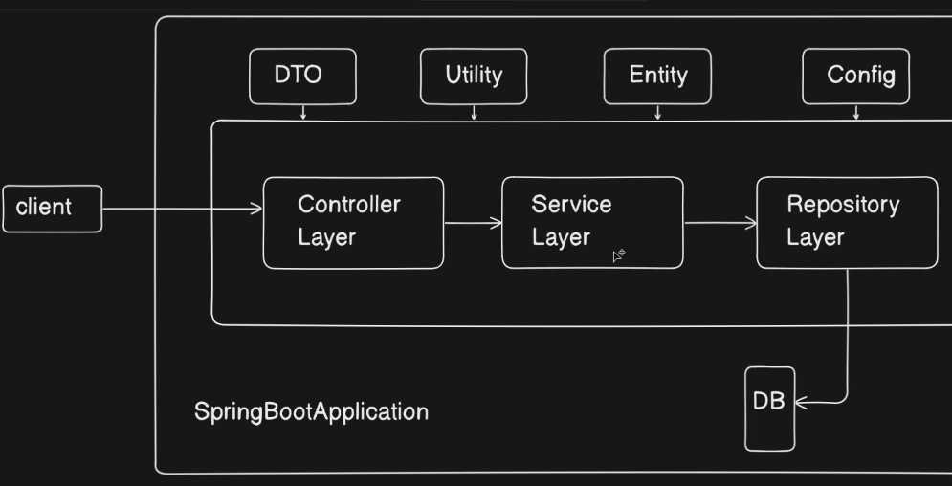
What Spring Boot Really Looks Like
A real backend application follows this flow:
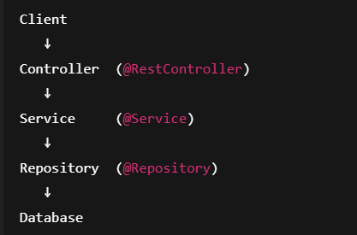
Spring enforces this through annotations.

Example — User Registration API
Let’s build a simple:
API : GET /users/{id}

Entity (Database Model)
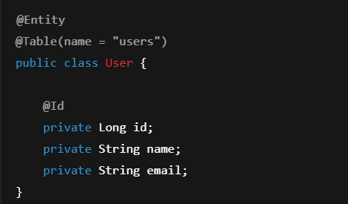
This maps to the DB table users.

DTO (What client sees)
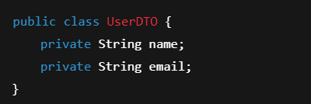
We never expose Entity directly.

Repository Layer
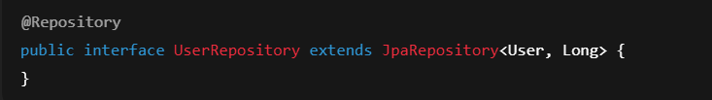
Why @Repository?
Spring converts SQL errors into Spring exceptions automatically.

Service Layer
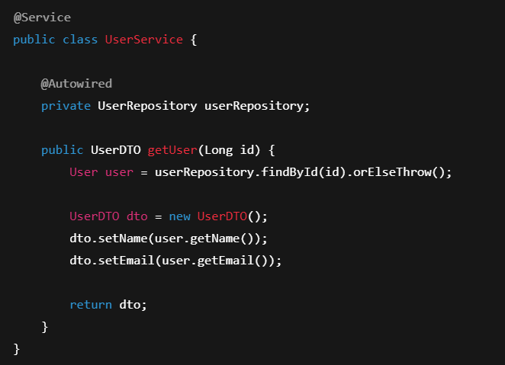
This is where:
- Business rules
- DTO ↔ Entity conversion
- Validation
live.

Controller Layer
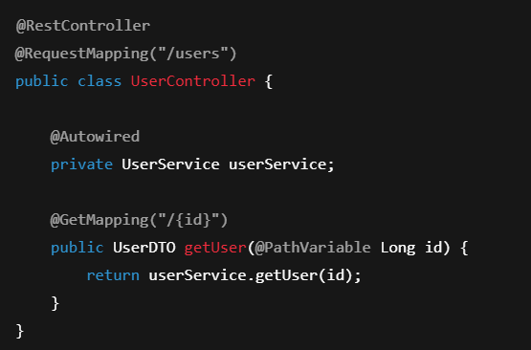
Controller:
- Talks to client
- Never touches database
- Never contains business logic

Where @Component Fits
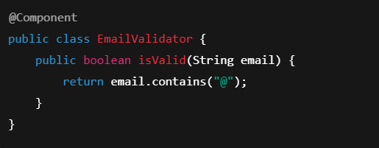
Used for:
- Utility classes
- Helpers
- Mappers
- Validators
Not business logic.
Not database.

Why Spring Cares About These Annotations
Annotation | Purpose | Extra Power
@Component | Generic bean | None
@Service | Business logic | Transaction support
@Repository | Data access | Exception translation

Interview Gold
Q: Can we replace @Service with @Component?
Yes — but you lose semantic meaning and AOP benefits.
Q: Why @Repository?
Because Spring wraps database exceptions only for @Repository beans.
Q: Where should DTO conversion happen?
Service layer.

Summary
@Component registers a bean,
@Service represents business logic,
@Repository represents database access with special behavior.

Interview-Grade One-Liner
“@Component just registers a bean, @Service represents business logic, and @Repository represents data access with special persistence behavior like exception translation.”

